增加产生式S’->A

0.S’->A

1.A->BaBb

2.A->DbDa

3.B->ε

4.D->ε

由产生式得

first(S’)={a,b}

first(A)={a,b}

first(B)={ ε}

first(D)={ ε}

follow(S’)={#}

follow(A)={#}

follow(B)={a,b}

follow(D)={a,b}

follow(D)={a,b}

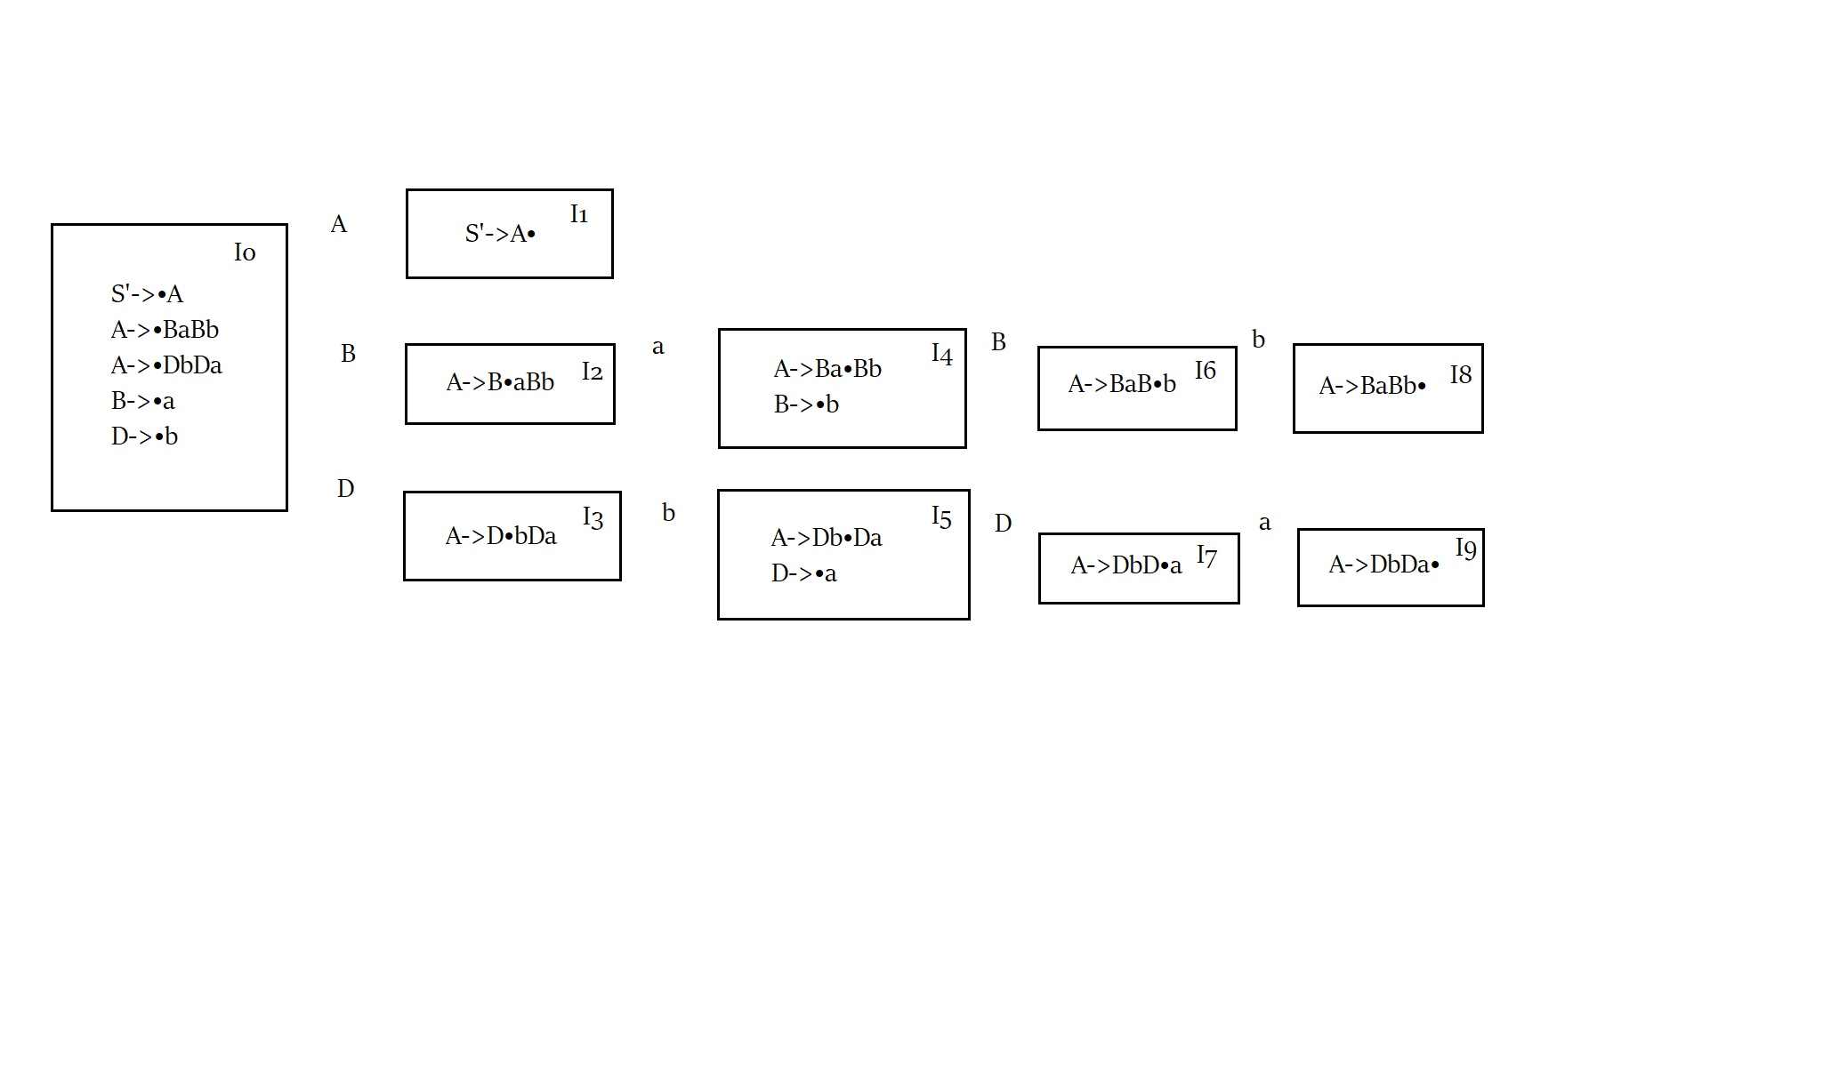

得LR（1）分析表

|  |  |  |  |  |  |  |
| --- | --- | --- | --- | --- | --- | --- |
|  | a | b | # | A | B | D |
| 0 | R3 | R4 |  | 1 | 2 | 3 |
| 1 |  |  | Acc |  |  |  |
| 2 | S4 |  |  |  |  |  |
| 3 |  | S5 |  |  |  |  |
| 4 | R3 | R3 | R3 |  | 6 |  |
| 5 | R4 | R4 | R4 |  |  | 7 |
| 6 |  | S8 |  |  |  |  |
| 7 | S9 |  |  |  |  |  |
| 8 |  |  | R1 |  |  |  |
| 9 |  |  | R2 |  |  |  |